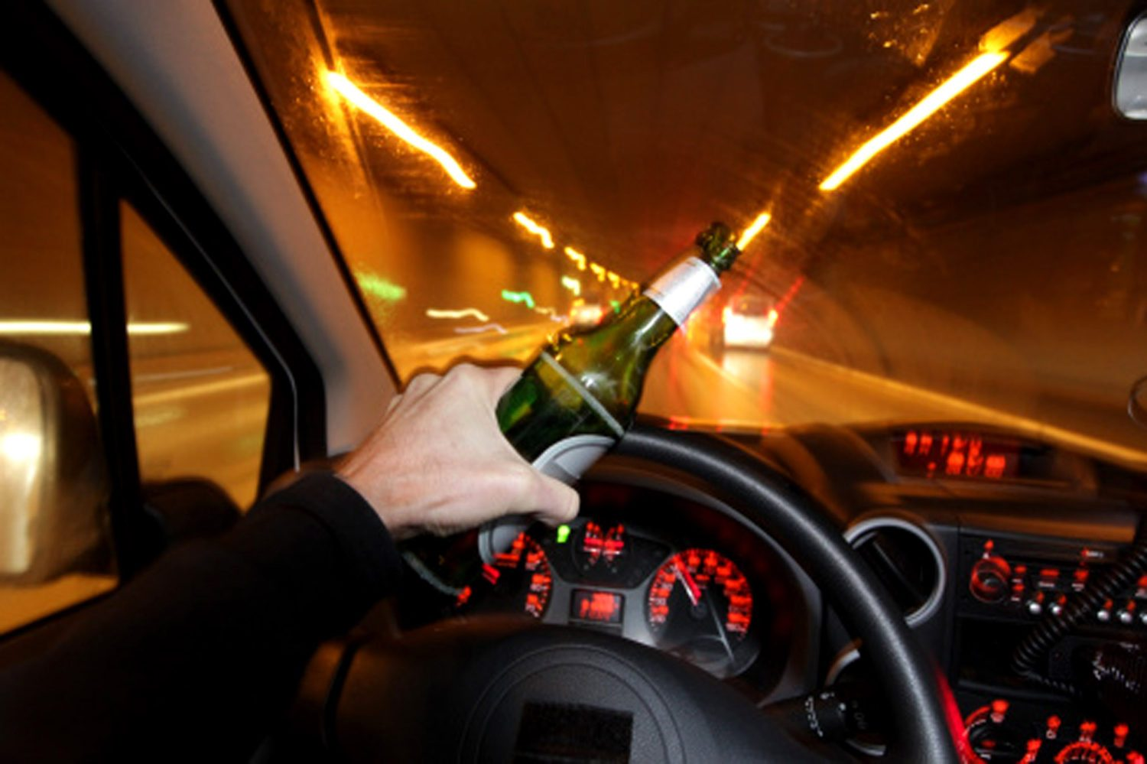

Drunk Driving
  - A LOOK INTO METHODS TO PREVENT DRIVING UNDER the INFLUENCE of alcohol

Kabir Kanha Arora | CCC 506 | 16th September 2018

(Dr. Who)

Problem Statement
Every year, more than 10, 000 people die within the United States alone due to drunk driving. It may be the drivers themselves who die, or the passengers who are with them in the car, or worse still, some innocent pedestrians who happened to be at the wrong place at the wrong time. Approximately 28% of all the road accident related deaths are caused by alcohol. Needless to say, it is high time that this menace is curbed and we put in measures that can help reduce this unnecessary loss of life.

Motivation
Having personally known people who have lost their loved ones in road accidents when they were Driving while Intoxicated (DWI) or Driving under Influence (DUI) and having seen the misery and grief that it can bring, or the never-ending legal implications, in case the injured party is one other than the one at the wheel, I felt motivated to take up this topic and on the 14th of September, Team ‘Dr. Who’ presented their study project on the title ‘Drunk Driving’
Note: To clarify right in the beginning, this study remains limited to alcohol, which is the biggest contributor to DUI accidents, and while we do understand that there are other intoxicants like drugs (both recreational and prescription), our focus of attention would not be on them and as of this report, we would limit ourselves to only alcohol, though some of the technology that I will talk about in this report may also be extended to the other categories, but we’ll leave that for a later date.

Stat Check

(NOTE: Due to ease of availability for data pertaining to the United States, all statistics and data published in this report would be from that context, unless explicitly specified. For e.g.: The Ministry of Road Transport and Highways of India says 16 persons die every hour across India in road accidents. But it makes no mention of the numbers who died due to drunk driving.)
- Every 2 minutes, someone is injured in a drunk driving crash. Every 51 minutes, someone is killed.
- Drunk driving crashes cost $130,000,000,000 every year.
- 35% of all night-time fatal car accidents were caused by a driver who was DUI.

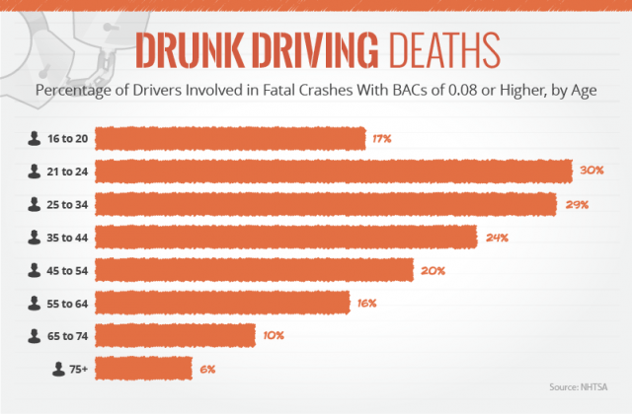
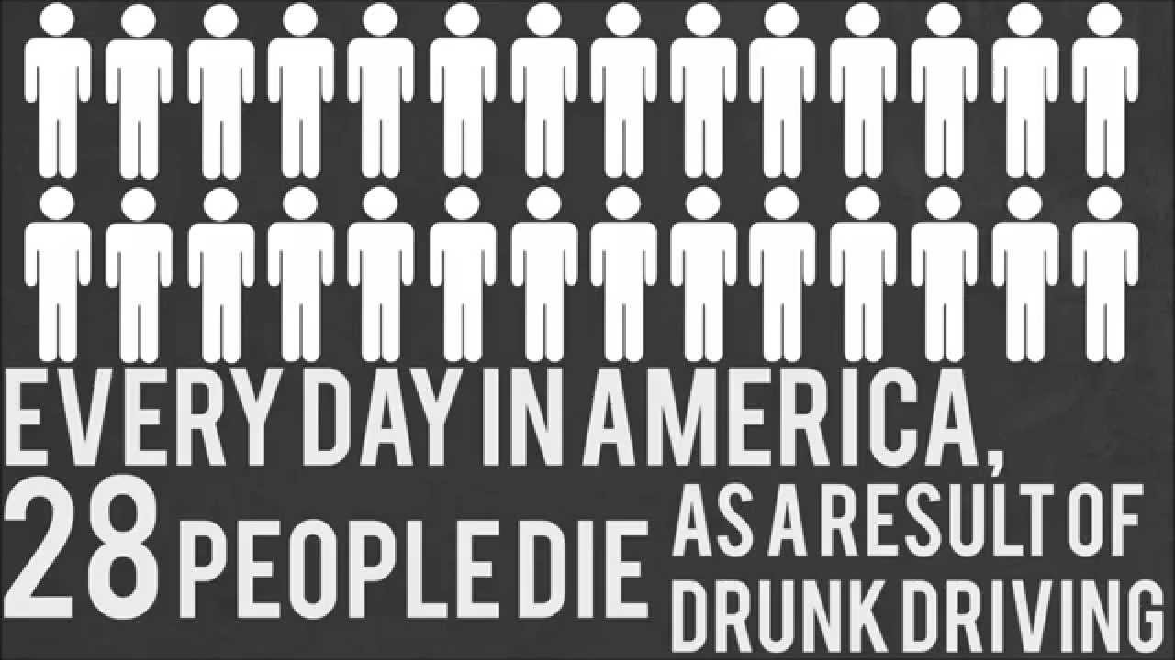
But why?

One might wonder - and it is perfectly alright to do so – that what is it that actually leads to this happening. Sure, we all know that drunk driving leads to accidents, but why is it so?
So, before moving on to the science behind it, let us take a look at the consequences of drinking a pint too many and why it may not be the best idea to drive soon afterwards.
Alcohol can have the following immediate effects on your body that render you unfit to drive a car, and doing so only endangers your life and those of others:

- Slow reaction time
- Lack of co-ordination
- Reduced concentration
- Hampered vision
- Inhibited judgement
- Giddiness
- Losing thread of what you’re saying
- Unsteady posture
- Seeing double

Now, the Science
Alcohol is a mood altering substance. It affects the nerves that pass messages around the body by slowing them down, and the more you drink the greater the effect. The reason people often get more lively when they’ve had a drink is that alcohol affects parts of the brain responsible for self-control.

As you drink, the alcohol passes into your bloodstream. Ethanol is the intoxicating part of alcohol and its molecules are so small that they can actually pass into the gaps between brain cells. There it can interfere with the neurotransmitters that enable all the brain’s activities. If you drink fast, alcohol will start to flood the brain.

Severe cases of heavy drinking can result in alcoholic poisoning, coma or death. If you’ve had a lot to drink you may also experience strong emotional responses - for instance you may become aggressive or tearful. And because your judgement is impaired, you may do things that you might not normally do - from dancing on tables to going home with strangers. They may seem a good idea at the time, but can be extremely dangerous.

The Legality of it

Blood alcohol content (BAC), also called blood alcohol concentration, blood ethanol concentration, or blood alcohol level, is most commonly used as a metric of alcohol intoxication for legal or medical purposes.
Blood alcohol concentration is usually expressed as a percentage of ethanol in the blood in units of mass of alcohol per volume of blood or mass of alcohol per mass of blood. For instance, a BAC of 0.1 (0.1% or one tenth of one percent) means that there are 0.10 g of alcohol for every 100 mL of blood.
The National Institute on Alcohol Abuse and Alcoholism (NIAAA) define the term "binge drinking" as a pattern of drinking that brings a person’s blood alcohol concentration (BAC) to 0.08 grams percent or above. This typically happens when men consume 5 or more drinks, and when women consume 4 or more drinks, in about 2 hours.
For purposes of law enforcement, blood alcohol content is used to define intoxication and provides a rough measure of impairment. Although the degree of impairment may vary among individuals with the same blood alcohol content, it can be measured objectively and is therefore legally useful and difficult to contest in court. Most countries disallow operation of motor vehicles and heavy machinery above prescribed levels of blood alcohol content.

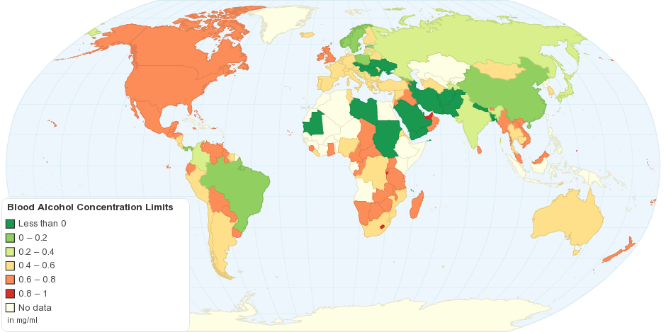

Legal BAC Limits by Country

Tech that can help detect drivers who are drunk
(NOTE: In the remainder of the report, I shall be talking about the various technologies that either exist in the market, or are in the early developmental stages and also, tech that our group came up with, which does not exist. It is obvious that not all of this can easily be implemented in the short run, but step-by-step, we can advance to a world with safer roads and some of these tech solutions may be easy to adopt and some not so easy, but assuming that not all of it needs to come into existence all at once, we can gradually start to implement all of them.)

App Data
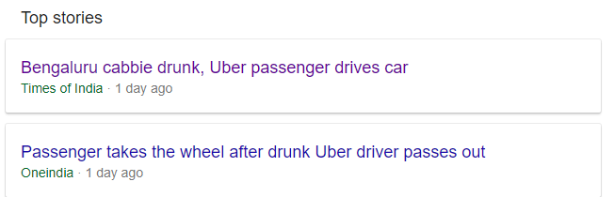

A lot of us may have had unpleasant experiences at some point in time with our Uber/Ola drivers. So what we proposed is an app that prevents riders from taking a ride with a driver in an inebriated condition, to ensure their safety. The app can detect the slur in the driver’s voice when he calls the passenger before the ride. Apart from the slur, other ways to determine whether the driver is drunk is if he is speaking at a low volume, high pitch, slow speed or with a lot of pauses.
Using Machine Learning and Artificial Intelligence, the app can tell whether the driver is in his senses or not. If the app determines the driver is might be drunk, it can prompt the user to either choose to confirm the ride or deny it, after seeing the driver. In the case that the app determines that the driver is most likely to be drunk, it can cancel the ride and suspend the driver until he is deemed fit and safe for driving again. In the worst case scenario, the app could alert the nearby PCR Van as well.
The voice recognition feature on the app serves another feature as well, the app only allows the driver to accept the ride if it matches his voice with the one in the database, to prevent an impersonator from driving. This can also be done by integrating a fingerprint confirmation, but that’s a topic for another day.
Another idea we had was to ask the driver to trace out a complicated line on his screen, something which he would not be able to do in an inebriated state, to confirm the ride.

Sensors

There are two infra-red technologies under current investigation by a research consortium, one system that is breath-based, another that is finger touch-based. The work is sponsored by NHTSA and the ACTS.
The project is called the Driver Alcohol Detection System for Safety, or DADSS.
The breath-based system is not like the breathalyzer used by police, which requires a deep-breath air sample for analysis. Rather, it takes a sample of the driver’s normal exhalation, which is primarily carbon dioxide. The sensor directs infra-red beams through it, and an electronic module analyzes the return waves. Because infra-red wavelengths vary according to the concentrations of different gasses through which they pass, the percentage of alcohol in the sample can be measured by the module.

The touch-based device, which likely would be built into an engine start button, illuminates and sends infra-red light through the skin into the capillaries of the fingertip. Like the breath-based system, infra-red beams are reflected back into the sensor. The touch-based system, using specific filters, looks for the two wavelengths that indicate the presence of alcohol—and only those wavelengths.

Also in the research stage is location of the sensor, with the driver’s side door, gear stick and steering column among the possibilities. In addition, the research teams are looking at the possible value or need to use more than one sensor, to identify locations that would positively separate the driver’s breath sample from those of passengers.

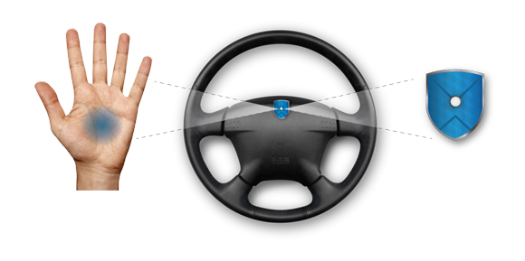
Both technologies have been developed to the points where they can take readings very quickly. The touch-type is being tuned to take several readings in under a second. The breath type is reportedly not nearly as fast, because of its type of operation (waiting for the driver to exhale), but the system response is instantaneous once the sample is taken.

Ensuring that a touch device is used by the driver alone will require a high level of verification that the actual driver is in the seat. It could be a combination of a facial-recognition sensor and a seated driver presence sensor. The system will not generate a valid engine-start signal if other than a seated driver presses the start button.

Upon finding the driver drunk, if it is a self-driving car, it would go into an automatic override mode, and park in a safe spot. Otherwise, a simpler solution could be to blare the horns and the parking light in a fixed pattern to indicate to the other drivers on the road that they should maintain a safe distance from that car. This technology would also help eradicate drinking while driving, since it would continuously monitor the exhalation of the driver, as well as the touch-based monitoring

Facial Recognition
How does one actually tell whether a person is drunk just by looking at him/her? More importantly, how does a machine do that?

Red flushed cheeks, narrowed eyes, sleepy looking, unsteadily balanced and leaning on someone could be some of the telltale signs.
But it’s mostly the eyes though.
Check the color of their face. Is it flushed? This is a dead giveaway for many East Asians but may not apply to other people.
Another drawback could be that some people get red just from a sip of alcohol or due to some other factor, but may not be drunk.
Check their eyes. Do they have the thousand-yard stare? If they're extremely drunk, they might even be slightly cross-eyed or have narrowed eyes.
Greek researchers at the University of Patras have developed a technology far more refined than what I have just spoken about. It works in the following ways:
First, it measures pixel values at specific points on the face. These points are some of the locations at which blood vessels beneath the skin dilate when alcohol has been consumed. This causes the skin to color in those places. When the software subsequently compares an individual’s facial coloration against a database of facial images of both inebriated and sober people, it can apparently determine whether or not that person is drunk – with reasonable accuracy.
Second, it utilizes thermal imaging technology to gauge the temperature of an individual’s nose and forehead. When people are inebriated, apparently, their noses get warm while their foreheads remain relatively cool. An algorithm within the software allows it to locate these facial features when presented with an image of a person’s face.
Sounds too cool to be true, doesn’t it?
Driving Behaviour

As we've seen earlier...

When driving under influence, you lose your sense of judgement and that could impair you from seeing how fast you're actually going, your reaction time is so slow that you could travel the length of a football field before you apply the brakes after seeing an obstacle at high speed.

It also affects your motor skills and hand eye coordination as well as vision which is why a drunk person finds it difficult to walk steadily.

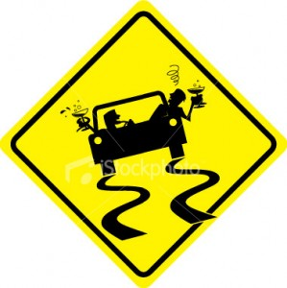

• Motion sensors and a camera mounted either on the front or back of the car would let the driver know if he is swerving and unable to stay in his lane. The motion sensors would detect sudden changes of direction and the cameras would keep track of how straight you're driving by tracking the markings on the road. Could work along with cruise control built into certain cars. And limit the speed of the car, keep it steady.

• Eye Tracking which utilises special sensors to know exactly where your eyes are focused. It determines your presence, attention, focus, drowsiness, consciousness or other mental states. Infrared light is directed towards the center of the eyes (pupil), causing visible reflections in the cornea. These reflections are tracked by an infrared camera. This will be used to detect the driver's level of concentration, how much attention he's paying to the road and whether he is feeling drowsy. The steering wheel or seat should vibrate to knock the driver out of his drowsy state and make him alert.

• Seat belt mechanism that tightens automatically according to signals received from the motion sensors and eye tracking system, or simply alerts the driver that he doesn't have his seatbelt on.

All these mechanisms will lead to an audio cue and could even lead to a text message/ call being made to an emergency contact, along with sharing of live location. For the safety of others on the road, if it is a self-driving car, it would go into an automatic override mode, and park in a safe spot. Otherwise, a simpler solution could be to blare the horns and the parking light in a fixed pattern to indicate to the other drivers on the road that they should maintain a safe distance from that car.
conclusion

Although, there is no guarantee that people would be willing to incorporate this technology into their cars, as and when the technology rolls around, I think it safe to say that the cab companies and the car rental companies would definitely be willing to invest money into such tech. From there, we can only hope that it catches on and spreads throughout the road. With the advent of cars that have become ‘smarter’, it’ll become easier to integrate such safety mechanisms and the hope is that someday, it’d become a legal requirement and the sensors could actually be linked to the police database, to catch those flouting the law, red-handed.
We firmly believe that driving is a privilege, and not a right and those who endanger others on the road have no right to drive.
Maybe not tomorrow, maybe not next year, but we hope to see a lot of these technologies in use in the real world within the next decade or so. Some of these, such as App Data, and Driver behavior may be slightly easier to implement, while the others may take a little longer.

references

http://feizylaw.com/index.php/2018/02/18/deadly-consequences-of-drunk-driving/
https://www.nhtsa.gov/
www.drinkingandyou.com/site/can/xdrunk.htm
https://www.sae.org/news/2018/05/tech-for-drunk-driving-prevention
https://auto.economictimes.indiatimes.com/news/auto-technology/now-a-new-device-to-prevent-drunk-driving/63849981
https://sociable.co/technology/new-tech-takes-aim-at-drunk-driving/
https://www.usatoday.com/story/money/cars/2015/07/06/new-technology-to-prevent-drunk-driving/29125417/
http://sobersteering.com/how-it-works/
https://en.wikipedia.org/wiki/Blood_alcohol_content#Legal_limits
http://icap.org/Table/BACLimitsWorldwide
https://newatlas.com/drunk-face-scanning-cameras/23993/
https://www.ncadd.org/about-addiction/driving-while-impaired-alcohol-and-drugs

